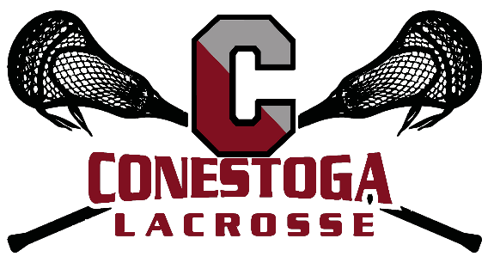

We hope you will consider sponsoring the upcoming Conestoga Lacrosse Parent Fundraiser which will be held on February 28, 2020 at La Cabra Brewing. This Fundraiser directly benefits the athletes on both the girls and boys teams. Proceeds from this annual event help with uniform and coaching needs, team-building activities, travel stipends and the purchase of safe equipment.
More details about sponsorship opportunities are outlined below.

Sponsorship Levels:

Presenting Sponsor $2500

- Acknowledgement on Main Entrance Banner, event flyers and website
- Full page ad in boys lacrosse yearbook
- 4 Admission Tickets

State Champs Sponsor $1000

- Acknowledgement on event signage and website
- ½ page ad in boys lacrosse yearbook
- Acknowledgement on event Tee Shirt

Central League Sponsor $500

- Acknowledgement on event Signage and website
- ¼ page ad in boys lacrosse yearbook
- Beer Sponsor

Table Top Sponsor $250

- Acknowledgement on Table Top at event
- 1/8 page ad in boys lacrosse yearbook

Please reach out to Ame Austin (4849190029, ameaustin16@yahoo.com), to discuss sponsorship opportunities.

Thank you for your consideration of this request and for your support of Conestoga Lacrosse!

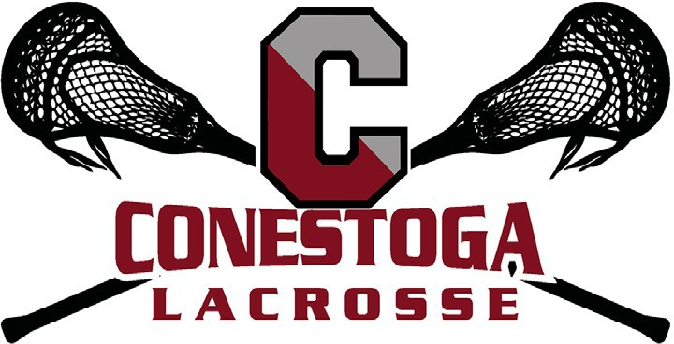

Conestoga Lacrosse Annual Fundraiser
Friday, February 28, 2020
La Cabra Brewery

SPONSORSHIP REQUEST FORM

We hope that you will consider sponsoring Conestoga Lacrosse’s Annual Parent Fundraiser directly benefitting the girls and boys lacrosse programs.
Company Name(s): ______________________________________________________________________________
Address: _________________________________________________________________________________________
Contact Person: _________________________________________________________________________________
Phone: ___________________________________ Email: _______________________________________________

Sponsorship Level (please check one):

Presenting Sponsor @ $2,500
State Champs’ Sponsor @ $1,000 Central League Sponsor @ $500
Table Top Sponsor @ $250
Please return completed sponsorship form along with payment by February 21, 2020 Online:
www.conestogalacrosse.com

Or By Mail:
c/o Boys Pioneer Lacrosse Club Attn: Bob Lee
743 West Valley Road Wayne, PA 19087
For more information, contact: Ame Austin
Boys Lacrosse Event Chair
Ameaustiin16@yahoo.com

Thank you for your support!
Donations are fully tax-deductible to the extent allowable by law. Conestoga Boys Lacrosse Boosters Club is a 501(c)(3) non-profit organization under Parent Booster USA Inc. (Federal EIN 45-5041996). Keep a copy of this form for your tax records

